Management Company Report Cards

On the Rental Compliance Reporting System (RCRS)

1. Log on to the Rental Compliance Reporting System.

2. From the Home screen, select **Reports** from the menu:

2. Select **Management Company Report Cards** from the Report List:  
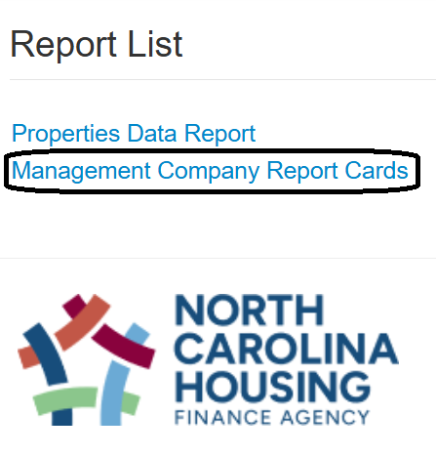

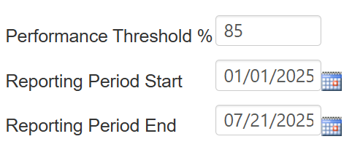3. Change any of the **Parameters**, as desired. This step is optional:

The Performance Threshold is 85%, by default.  
  
The Period Start Date is January 1, 2025, by default and can be set to a later date, but not an earlier one.

The Period End Date is yesterday, by default, and can be set to an earlier date, but not today or later.

4. **Exclude** properties, if desired. Excluded properties are highlighted with a gray background in the list and they will not be included in the report card. This step is optional:

* The default is **None**, which means the report will be run for all properties. The selection **None** is highlighted.
* To exclude **one** property, click the property name to select it. The property is highlighted.
* To exclude a **range** of properties, press and hold the **shift button**, then click the first property in the range. While still pressing the shift button, click the last property in the range. All of the properties in the range will be highlighted.
* To exclude **multiple** non-contiguous properties, press and hold the **ctrl button**, then click each property to be excluded. Every selected property will be highlighted.

5. Once all of the selections are complete, click on one of the four **Report Cards** to be generated.

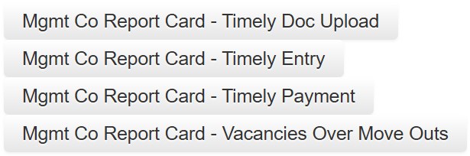

6. The Report Card will be downloaded to your computer as a Word document (docx file type). You may be prompted to select a file location first. To view the Report Card, navigate to the folder and open the document. Alternatively, if you see a window with a download icon, you can click the icon or the file name directly below it to open the Report Card. You can close this window once the download is complete.  
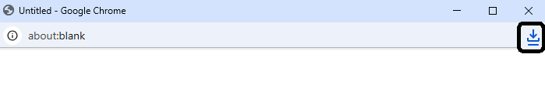

7. To run a new Report Card with the same selections, just return to your browser window, the one with the Management Company Report Cards screen, and select a different Report Card. The web page will keep the parameters you entered until you select a different web page, your login times out, or you close your browser.

Frequently Asked Questions

*I clicked on a report card but nothing happened. Why?*  
The browser is probably set to block Pop-up Windows and Redirects. You may see an icon like this:   
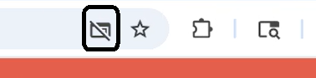

*How do I change this setting so I can get my Report Card?*One way is to click the icon and select the “Always allow” option  
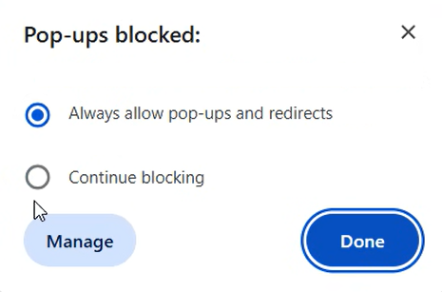

*Why isn’t the Report Card in my Downloads folder?*Confirm the default location in your browser settings. It may not be configured to use your Downloads folder.

*What do all of the numbers in the file name mean?* *For example, 2025_07_23_10_06_RCRS_TimelyEntry*The numbers tell you the date and time the Report Card was generated. In this example, the report was run at 10:06 am on July 23, 2025.

*Why is a property missing from the report?*The primary reason is because that property does not have any activity for the date range specified.

*Will a missing property impact my score?*No

*I just updated RCRS with new information but I don’t see it in my report. Why?*The Report Card data is as of last night. Anything you enter today will appear in the Report Card tomorrow.

*The Report Cards are summarized. How do I get the unit details?*A separate report will be released that gives the breakdown used in the calculation. Please don't email Agency staff since they won't have access to the report until it's made available in RCRS.